**Verification Code of Practice**

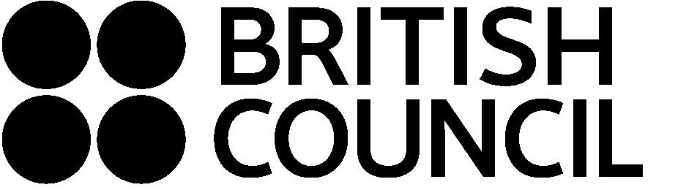

**The Verification of British Educational Documents in Macedonia**

**CODE OF PRACTICE**

**Aim**

To agree, and apply policies for document verification that help protect the integrity of British education by ensuring that forged documents and documents emanating from bodies not having recognized academic or professional status are not endorsed by UK authorities.

1. **Verification process**

The British Council will require your original documents to provide this service. We will hold these securely until the service is complete and the documents can be returned to you. We will also need to send copies of your document to the issuing bodies. This may be done either physically or electronically. If any fraud is discovered we will also pass details on to the relevant legal bodies.

Following completion of the service, we will retain a copy for our records. We will also record your name, type of document, the date of transaction and any other relevant details for our records. This will be kept securely and will not be provided to any other parties unless we are legally required to do so.

The British Council can only sign or stamp your document so that you can send verified copies to the UK.

The steps are as follows:

* you can bring the original documents (diploma) to our office,
* we will scan the document and email this to the awarding body requesting they confirm that they issued the document
* on receipt of this confirmation, we will stamp the original document with the standard verification stamp and sign it

**B. Nationality of issuing body**

1. Only documents issued by British bodies and relating to British education can be verified. Documents from Macedonian, or other non-British bodies, cannot be verified.

**C. Status of issuing body**

1. Only documents from British bodies that have official or recognized academic or professional status in Britain can be verified.

Please note that we are open from Monday to Fridays between 10.00-14.00 h.

The verification service costs 1,800 MKD per document.

British Council Macedonia